













**VOLLEYBALL STATS**

The volleyball teams played On Monday, October 17 against Columbus at Columbus and had a clean sweep! Make sure to come watch the Brahmanettes play their next home game against LaGrange on Monday, October 31st. This will be the last game of the season So make sure to come out and support them!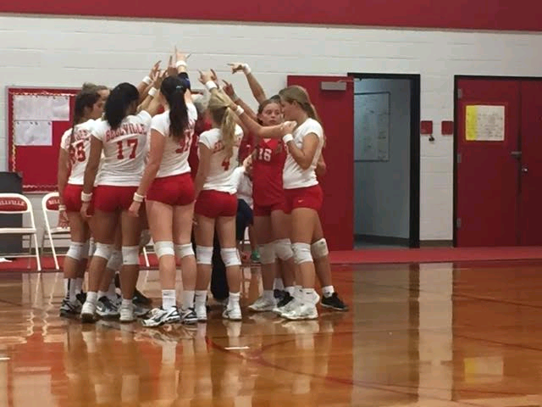

**WHAT’S HAPPENING AT BJH?**

Mr. Symm gets wrapped from head to toe in toilet paper!

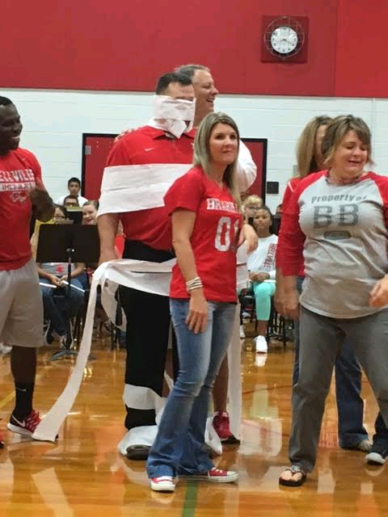



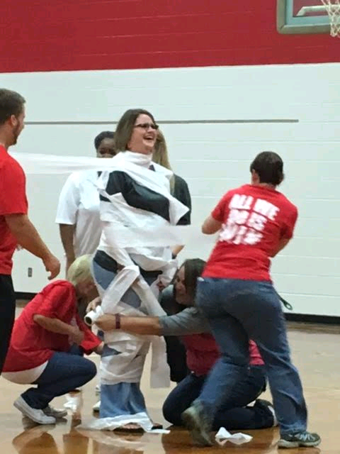

Mrs. Jones gets wrapped in toilet paper competition during the first pep-rally of the year!



**Colby Lange**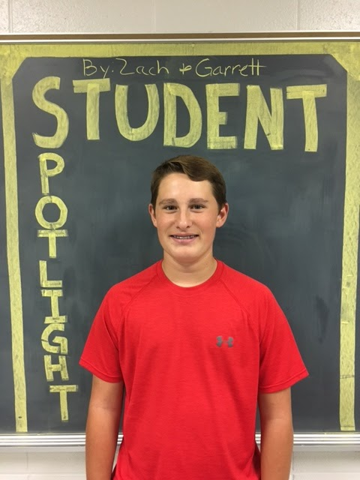

We asked Colby a few questions and learned that his favorite teacher just so happens to be his own mother.He also admitted that he’s an awful “ secret keeper” who loves chocolate ice cream. And our last question revealed that if he could save anything in his room during a flood, it’d be his phone.

**Callie Fishbeck**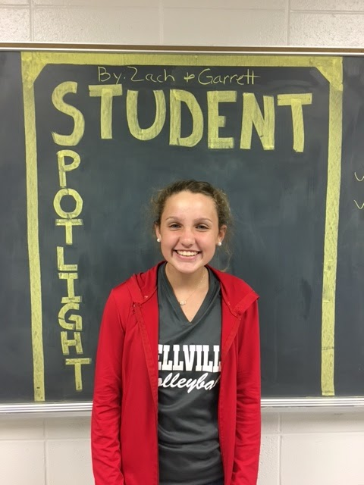

The next student we interviewed was Callie. The first thing we asked her was if she could go anywhere, she would go to England. Good thing she would keep her eyesight if she could only keep one sense. But for someone who enjoys reading on rainy days, I don’t think anyone would’ve expected her celebrity crush to be the Texans, JJ Watt.

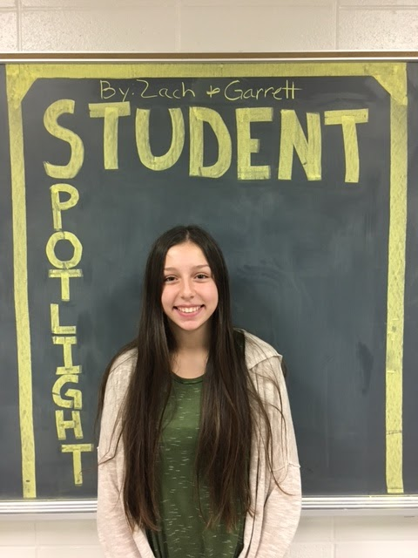

**Jolie Holcomb**

The last but certainly not least person we interviewed was Jolie. The first question asked was, if she won 100 million dollars what would she buy first. She said she would go to London. Also if she could ask one question to the president, it would be what his favorite color was. Her favorite cartoon character is Spongebob and her favorite color of grapes are red.

